TITLE OF THE PAPER
Ivana Petrović
Belgrade Metropolitan University, Faculty of Information Technologies, ivana.petrovic@metropolitan.ac.rs
Lazar Todorović
University of Belgrade, Faculty of Mechanical Engineering, lazar.todorovic@gmail.com

Abstract: This document presents a template for preparing the papers that will be included in the Proceedings for BISEC 2016 conference. We strongly recommend that your papers be in the form of this template. The maximum number of words allowed for this abstract is 150 words.
Keywords: Information Security, IoT, Critical Infrastructure Systems

1. INTRODUCTION
A paper submitted for publication to the Proceedings of the BISEC conference 2016 should be an original work that should not have been previously published and has not been under consideration for publication elsewhere. All papers are written in English. The paper should be typed in a word processor (Microsoft Word, Open Office Writer, LibreOffice Writer, Pages for Mac, Latex, etc.), orientation portrait, page size A4 (210x297mm).
These instructions must be used for text processing. The instructions define the page layout, as well as styles to be used in formatting.
All margins need to be 2 cm (top, bottom, left and right). There should be the conference logo at the top of the page (as in this template).
The text of the paper should be in two columns, column width 8.25 and with 0.5 spacing between the columns, without indenting the first line. The text should be typed with single spacing and add space between paragraphs (6 pt).
Maximum number of pages is 6, including images, tables, graphs, references and appendices. This limitation does not apply to keynote papers.
No page numbers.
2. FormatiNG THE PAPER
The title of the paper is centred, Times New Roman, bold 14pt.
Beneath the title of the paper, the name(s), affiliation and e-mail address should be typed.
Beneath the title of the paper and names of authors, there should be a short abstract in English, whole page wide, italics (as presented in these instructions).
For text formation, the font Times New Roman should be used in the following sizes and styles:
- Title of the paper, 14 pt bold, all caps
- Names of authors, affiliation and e-mail 10 pt
- Abstract, 10 pt italic
- Key words, 10 pt italic
- Numbered headings in the paper 11 pt bold, capital letters
- Subtitles in the paper, 11 pt italics, normal
- Text 10 pt
3. EQUATIONS
Equations should be written in a single column, aligned right, as in
(1)
If it is necessary not to break the equations, they should be typed on the whole width of the page (single column), but after that, it is necessary to continue typing the text in two columns.
4. GRAPHICS
Images, tables and other graphic units should be adapted to the width of a single column. If one column is not sufficient, the width of the whole page should be used, but the text should be typed in two columns after that.
Numbering images and graphs
The caption and the number of an image or a graph should be centered in the line below the image.

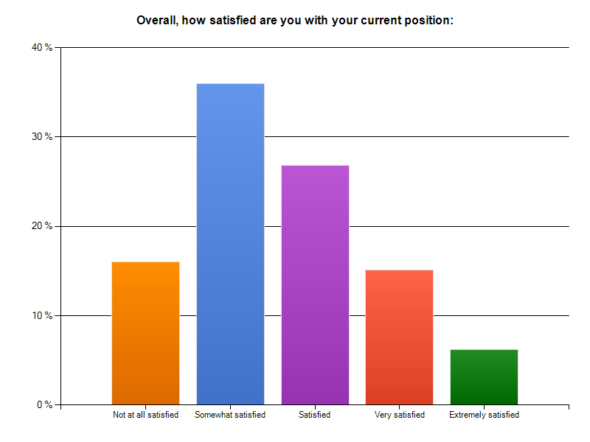Image 1: Heading of a graph
Labelling tables
The position of headings and numbers of tables (captions) should be written in the line above the table, aligned left.
Table 1: Heading of the table
Incident | Number of attacks
I | 800
II | 25000
III | 55

5. CONCLUSION
The conclusion should not be longer than a single column. It should restate your thesis or summarize your main points from the paper.
REFERENCES
A numbered list of references must be provided at the end of the paper. The list should be arranged in the order of citation in text, not in alphabetical order. List only one reference per reference number. In text, each reference number should be enclosed by square brackets. Citations of references may be given simply as “in [1] ...”, rather than as “in reference [1] ...”. Similarly, it is not necessary to mention the authors of a reference unless the mention is relevant to the text. It is almost never useful to give dates of references in text. Only titles directly related to the topic of the paper should be quoted.
Footnotes or other words and phrases that are not part of the reference format do not belong on the reference list. Phrases such as “For example,” should not introduce references in the list, but should instead be given in parentheses in text, followed by the reference number, i.e., “For example, see [5].”
Sample correct formats for various types of references are as follows:
Books:
[1] G. O. Young, “Synthetic structure of industrial plastics,” in Plastics, 2nd ed., vol. 3, J. Peters, Ed. New York: McGraw-Hill, 1964, pp. 15–64.
[2] W.-K. Chen, Linear Networks and Systems. Belmont, CA: Wadsworth, 1993, pp. 123–135.
Periodicals:
[3] J. U. Duncombe, “Infrared navigation—Part I: An assessment of feasibility,” IEEE Trans. Electron Devices, vol. ED-11, pp. 34–39, Jan. 1959.
[4] E. P. Wigner, “Theory of traveling-wave optical laser,” Phys. Rev., vol. 134, pp. A635–A646, Dec. 1965. [5] E. H. Miller, “A note on reflector arrays,” IEEE Trans. Antennas Propagat., to be published.
Articles from Conference Proceedings (published):
[6] D. B. Payne and J. R. Stern, “Wavelength-switched passively coupled single-mode optical network,” in Proc. IOOC-ECOC, 1985, pp. 585–590.
Papers Presented at Conferences (unpublished):
[7] D. Ebehard and E. Voges, “Digital single sideband detection for interferometric sensors,” presented at the 2nd Int. Conf. Optical Fiber Sensors, Stuttgart, Germany, Jan. 2-5, 1984.
Standards/Patents:
[8] G. Brandli and M. Dick, “Alternating current fed power supply,” U.S. Patent 4 084 217, Nov. 4, 1978.
Technical Reports:
[9] E. E. Reber, R. L. Mitchell, and C. J. Carter, “Oxygen absorption in the Earth’s atmosphere,” Aerospace Corp., Los Angeles, CA, Tech. Rep. TR-0200 (4230-46)-3, Nov. 1968.

